Parallelogram
# Source: AI Source: Provided by: [Data Path: Persons Table -> ID Column: 1, Name_En Column: Motasem Essam] -> From: [ChatGPT] on [7/25/2026]
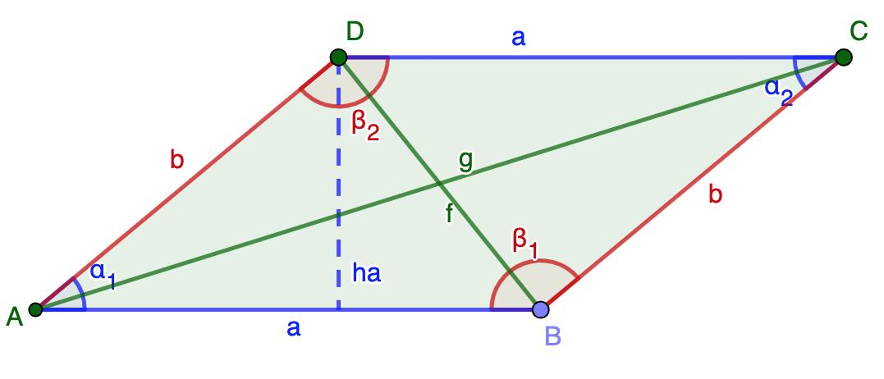
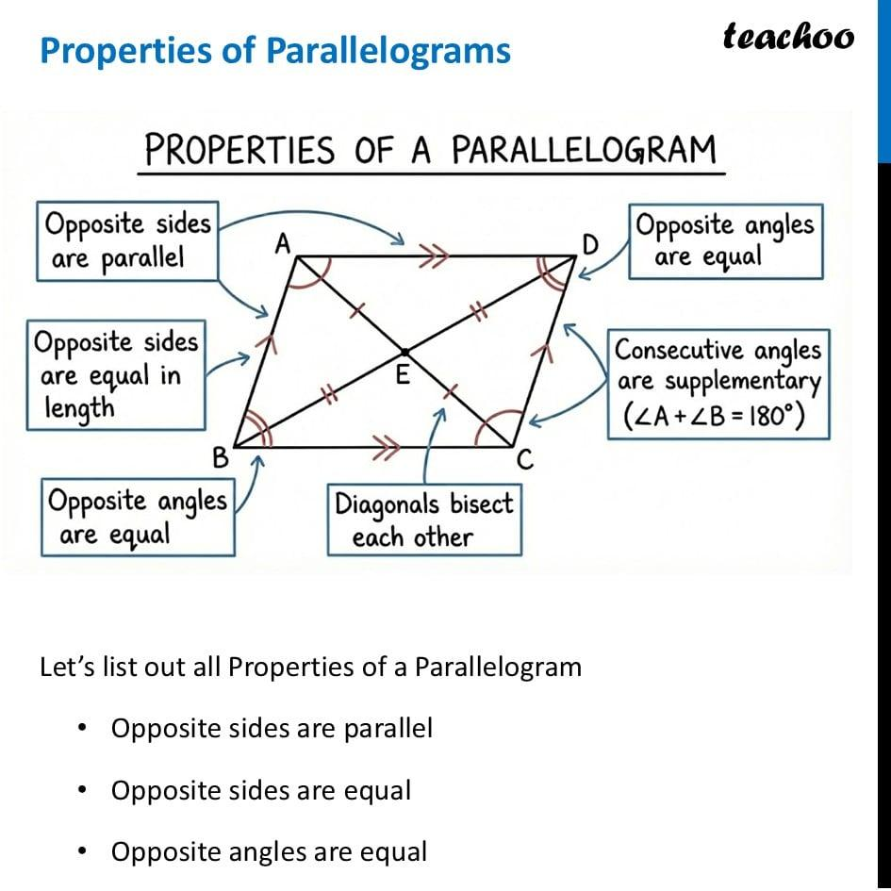
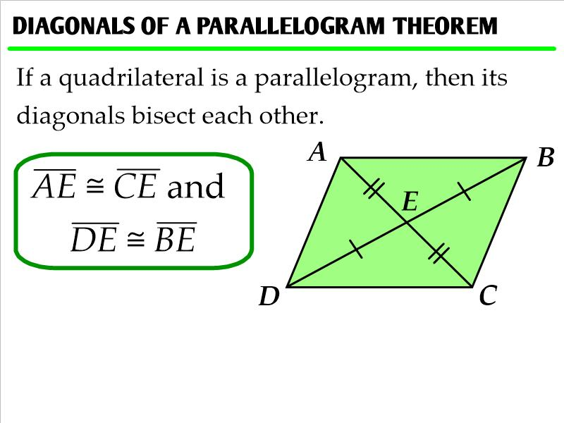
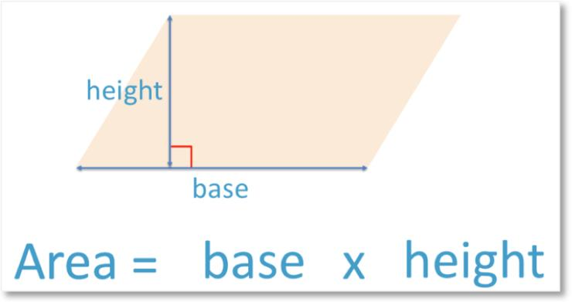

Definition
# Source: AI Source: Provided by: [Data Path: Persons Table -> ID Column: 1, Name_En Column: Motasem Essam] -> From: [ChatGPT] on [7/25/2026]
A parallelogram is a quadrilateral with two pairs of opposite sides parallel.
For parallelogram $ABCD$:
$$\boxed{AB∥CD}$$
and
$$\boxed{AD∥BC}$$
The opposite sides are also congruent:
$$\boxed{AB=CD} \\ \boxed{AD=BC}$$

Purpose
# Source: AI Source: Provided by: [Data Path: Persons Table -> ID Column: 1, Name_En Column: Motasem Essam] -> From: [ChatGPT] on [7/25/2026]
Parallelograms are used to:
- Study parallel and opposite sides.
- Analyze relationships between angles.
- Study diagonals and their intersection.
- Calculate perimeter and area.
- Understand special quadrilaterals such as rectangles, rhombi, and squares.
- Model structures and shapes in geometry, engineering, and architecture.

Fundamental Elements
# Source: AI Source: Provided by: [Data Path: Persons Table -> ID Column: 1, Name_En Column: Motasem Essam] -> From: [ChatGPT] on [7/25/2026]
Consider parallelogram $ABCD$.
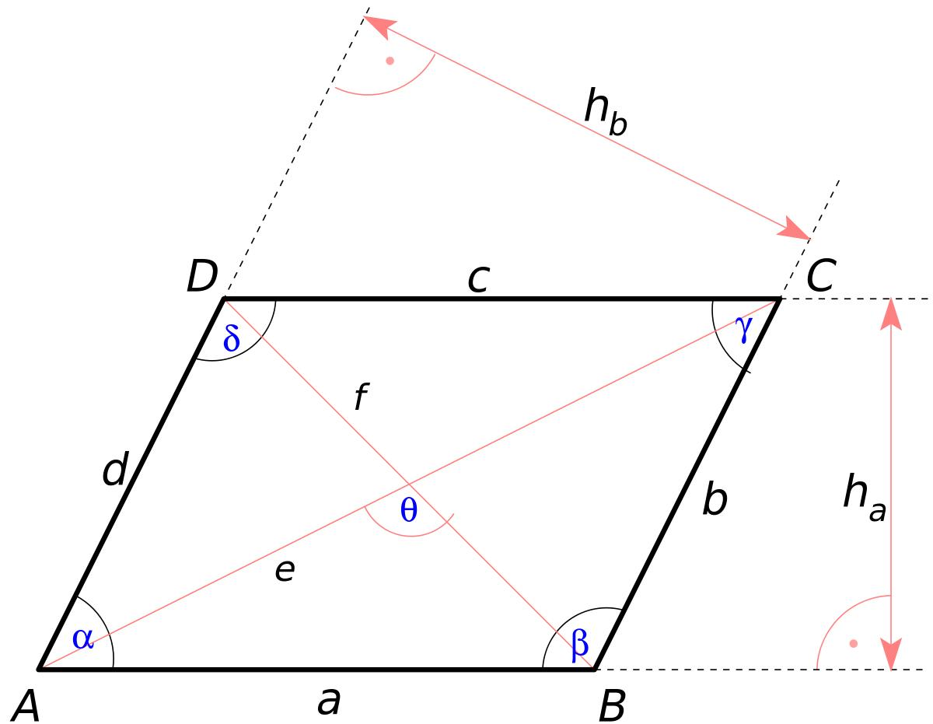
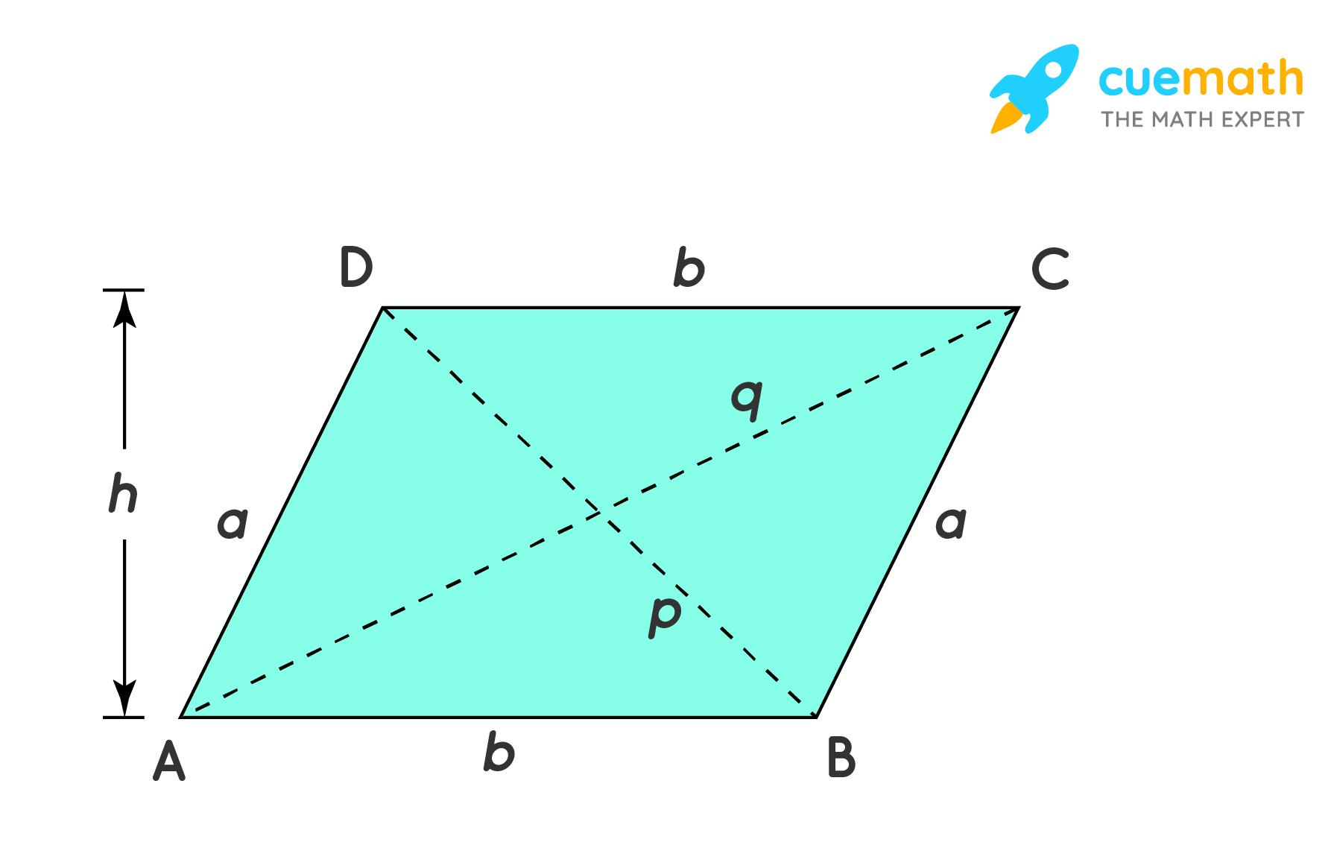
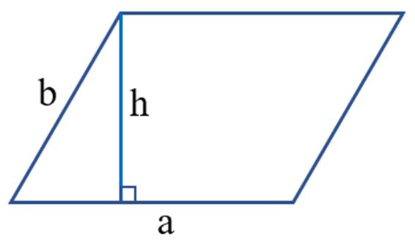
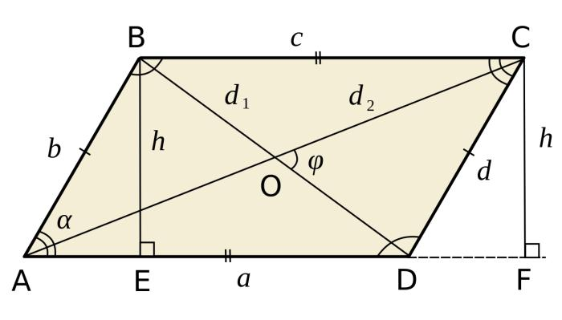
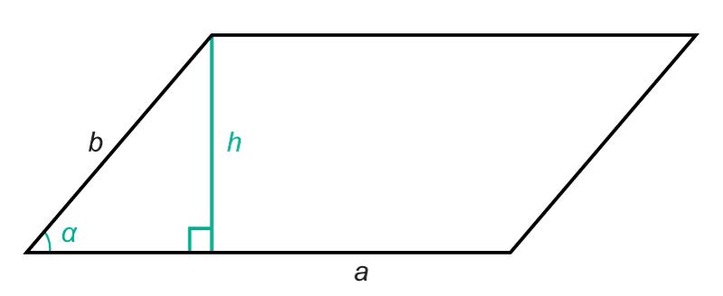

1. Sides
# Source: AI Source: Provided by: [Data Path: Persons Table -> ID Column: 1, Name_En Column: Motasem Essam] -> From: [ChatGPT] on [7/25/2026]
The four sides are:
$$\overset{‾}{AB}, \overset{‾}{BC}, \overset{‾}{CD}, \overset{‾}{DA}$$
Opposite sides are parallel and congruent:
$$AB∥CD \\ BC∥AD$$
and:
$$AB=CD \\ BC=AD$$

2. Vertices
# Source: AI Source: Provided by: [Data Path: Persons Table -> ID Column: 1, Name_En Column: Motasem Essam] -> From: [ChatGPT] on [7/25/2026]
The vertices are:
$$A, B, C, D$$

3. Interior Angles
# Source: AI Source: Provided by: [Data Path: Persons Table -> ID Column: 1, Name_En Column: Motasem Essam] -> From: [ChatGPT] on [7/25/2026]
The four interior angles are:
$$∠A, ∠B, ∠C, ∠D$$

4. Diagonals
# Source: AI Source: Provided by: [Data Path: Persons Table -> ID Column: 1, Name_En Column: Motasem Essam] -> From: [ChatGPT] on [7/25/2026]
The two diagonals are:
$$\overset{‾}{AC}$$
and:
$$\overset{‾}{BD}$$

5. Base and Height
# Source: AI Source: Provided by: [Data Path: Persons Table -> ID Column: 1, Name_En Column: Motasem Essam] -> From: [ChatGPT] on [7/25/2026]
A base can be any one of the sides.
The height is the perpendicular distance between the pair of parallel sides.
$$\boxed{h⊥b}$$
The height is not generally equal to the slanted side.

Fundamental Properties
# Source: AI Source: Provided by: [Data Path: Persons Table -> ID Column: 1, Name_En Column: Motasem Essam] -> From: [ChatGPT] on [7/25/2026]
A parallelogram has four major properties.
Property 1: Opposite Sides Are Parallel
$$\boxed{AB∥CD} \\ \boxed{AD∥BC}$$
Property 2: Opposite Sides Are Congruent
$$\boxed{AB=CD} \\ \boxed{AD=BC}$$
Property 3: Opposite Angles Are Congruent
$$\boxed{∠A=∠C} \\ \boxed{∠B=∠D}$$
Property 4: Diagonals Bisect Each Other
If the diagonals intersect at $O$:
$$\boxed{AO=OC}$$
and:
$$\boxed{BO=OD}$$

Consecutive Angles
# Source: AI Source: Provided by: [Data Path: Persons Table -> ID Column: 1, Name_En Column: Motasem Essam] -> From: [ChatGPT] on [7/25/2026]
Consecutive angles of a parallelogram are supplementary.
Therefore:
$$\boxed{∠A+∠B={180}^{∘}}$$
Similarly:
$$∠B+∠C={180}^{∘} \\ ∠C+∠D={180}^{∘} \\ ∠D+∠A={180}^{∘}$$
Example
If:
$$∠A={70}^{∘}$$
then:
$$∠B={180}^{∘}-{70}^{∘} \\ \boxed{∠B={110}^{∘}}$$
Because opposite angles are congruent:
$$\boxed{∠C={70}^{∘}}$$
and:
$$\boxed{∠D={110}^{∘}}$$

Interior Angle Sum
# Source: AI Source: Provided by: [Data Path: Persons Table -> ID Column: 1, Name_En Column: Motasem Essam] -> From: [ChatGPT] on [7/25/2026]
Like every quadrilateral, the interior angles of a parallelogram add up to:
$$\boxed{{360}^{∘}}$$
For example:
$${70}^{∘}+{110}^{∘}+{70}^{∘}+{110}^{∘}={360}^{∘}$$

Diagonals
# Source: AI Source: Provided by: [Data Path: Persons Table -> ID Column: 1, Name_En Column: Motasem Essam] -> From: [ChatGPT] on [7/25/2026]
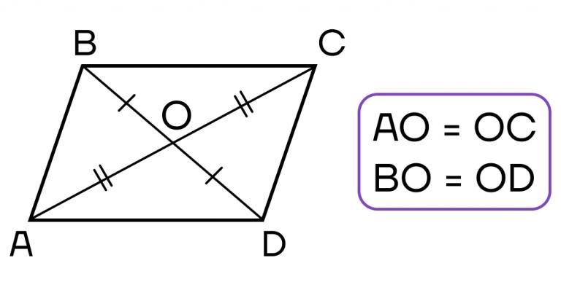
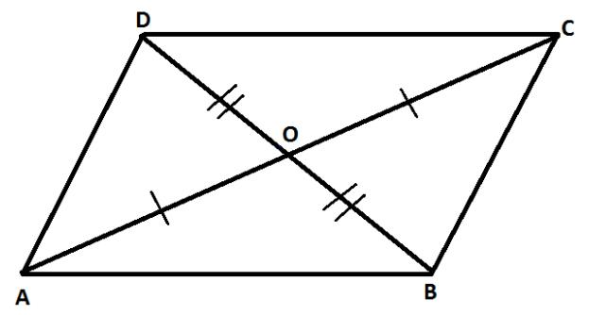
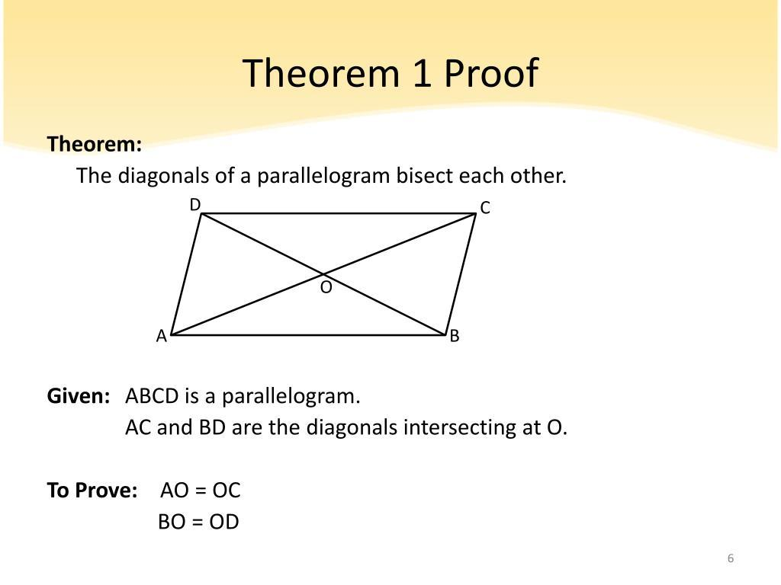
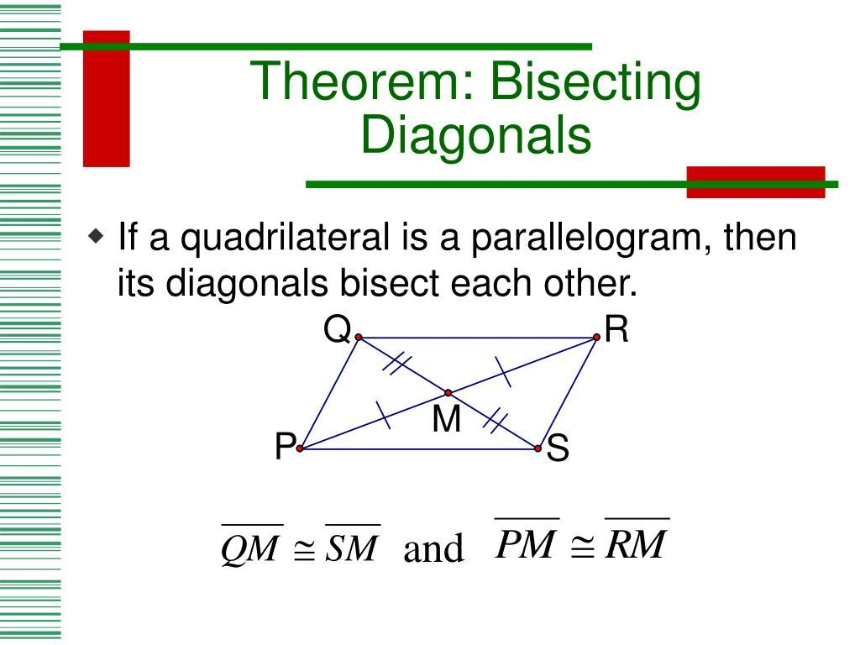
The diagonals of a parallelogram bisect each other.
If:
$$O=AC∩BD$$
then:
$$\boxed{AO=OC}$$
and:
$$\boxed{BO=OD}$$
Important distinction
The diagonals of a general parallelogram are not necessarily congruent.
They are congruent in a rectangle and therefore also in a square.
They are perpendicular in a rhombus and therefore also in a square.

Perimeter
# Source: AI Source: Provided by: [Data Path: Persons Table -> ID Column: 1, Name_En Column: Motasem Essam] -> From: [ChatGPT] on [7/25/2026]
If the adjacent side lengths are $a$and $b$:
$$\boxed{P=2a+2b}$$
or:
$$\boxed{P=2\left(a+b\right)}$$
Example
Suppose:
$$a=8\text{ cm}$$
and:
$$b=5\text{ cm}$$
Then:
$$P=2\left(8+5\right) \\ P=26 \\ \boxed{P=26\text{ cm}}$$

Area
# Source: AI Source: Provided by: [Data Path: Persons Table -> ID Column: 1, Name_En Column: Motasem Essam] -> From: [ChatGPT] on [7/25/2026]
The area of a parallelogram is:
$$\boxed{A=bh}$$
where:
- $b$= base
- $h$= perpendicular height
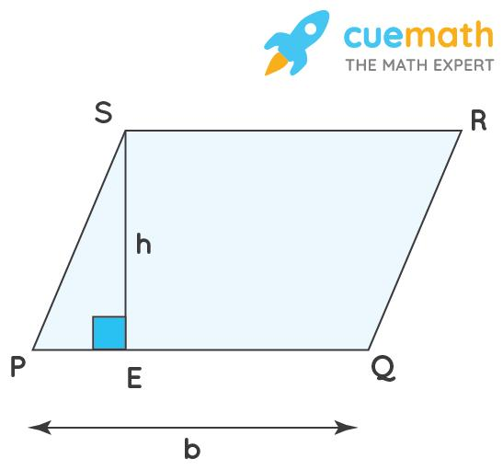
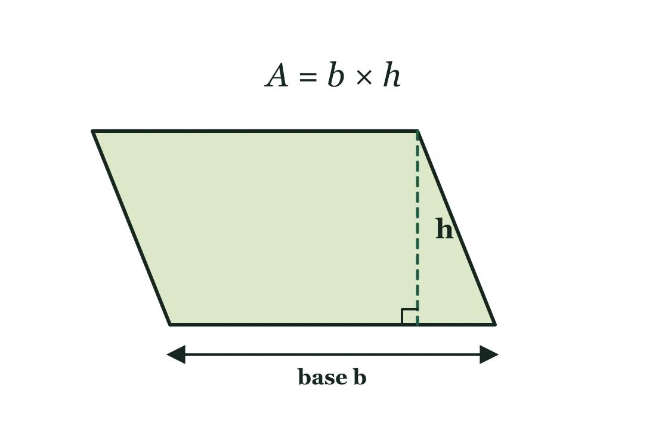
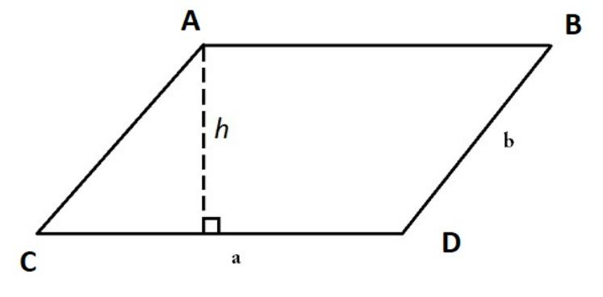
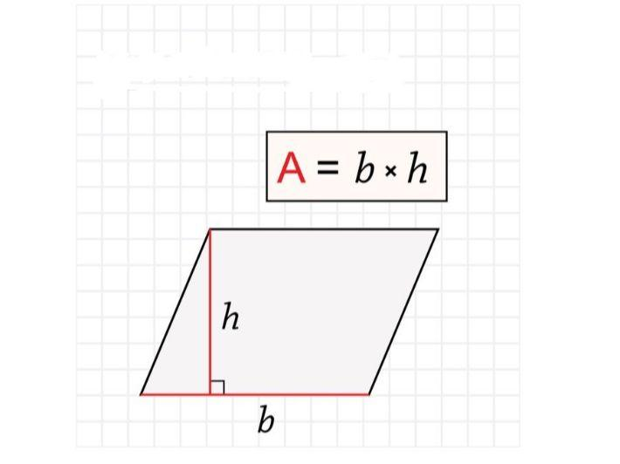
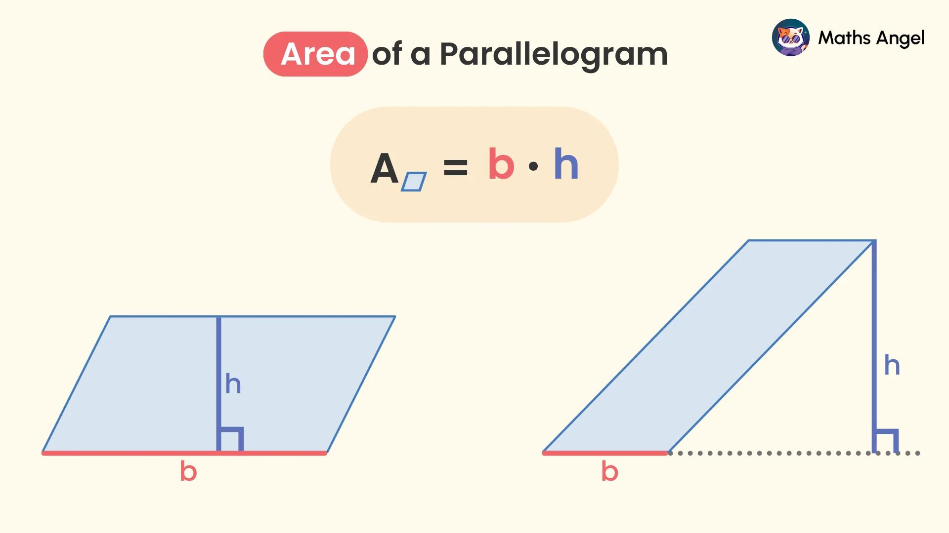
Important
The height must be perpendicular to the base.
It is not necessarily the length of the adjacent slanted side.
Example
If:
$$b=12\text{ cm}$$
and:
$$h=7\text{ cm}$$
then:
$$A=12\left(7\right) \\ \boxed{A=84{\text{ cm}}^{2}}$$

Area Using Two Sides and an Included Angle
# Source: AI Source: Provided by: [Data Path: Persons Table -> ID Column: 1, Name_En Column: Motasem Essam] -> From: [ChatGPT] on [7/25/2026]
If two adjacent sides have lengths $a$and $b$, and the included angle is $θ$:
$$\boxed{A=ab\sin{θ}}$$
Example
Suppose:
$$a=10\text{ cm}, b=6\text{ cm}$$
and:
$$θ={30}^{∘}$$
Then:
$$A=\left(10\right)\left(6\right)\sin{{30}^{∘}} \\ A=60\left(\frac{1}{2}\right) \\ \boxed{A=30{\text{ cm}}^{2}}$$

Relationship Between Base, Height, and Side
# Source: AI Source: Provided by: [Data Path: Persons Table -> ID Column: 1, Name_En Column: Motasem Essam] -> From: [ChatGPT] on [7/25/2026]
If the adjacent side has length $a$and the angle between the base and that side is $θ$, then the height is:
$$\boxed{h=a\sin{θ}}$$
Therefore:
$$A=bh$$
becomes:
$$A=ab\sin{θ}$$

Parallelogram and Rectangle
# Source: AI Source: Provided by: [Data Path: Persons Table -> ID Column: 1, Name_En Column: Motasem Essam] -> From: [ChatGPT] on [7/25/2026]
A rectangle is a special type of parallelogram.
Both have:
- Two pairs of parallel opposite sides.
- Opposite sides congruent.
- Opposite angles congruent.
- Consecutive angles supplementary.
- Diagonals that bisect each other.
A rectangle additionally has:
$$\boxed{4\text{ right angles}}$$
Therefore:
$$\boxed{\text{Every rectangle is a parallelogram}}$$
but:
$$\boxed{\text{Not every parallelogram is a rectangle}}$$

Parallelogram and Rhombus
# Source: AI Source: Provided by: [Data Path: Persons Table -> ID Column: 1, Name_En Column: Motasem Essam] -> From: [ChatGPT] on [7/25/2026]
A rhombus is a special type of parallelogram.
Both have:
- Opposite sides parallel.
- Opposite sides congruent.
- Opposite angles congruent.
- Diagonals that bisect each other.
A rhombus additionally has:
$$\boxed{\text{Four congruent sides}}$$
Its diagonals are also perpendicular and bisect the angles.

Parallelogram and Square
# Source: AI Source: Provided by: [Data Path: Persons Table -> ID Column: 1, Name_En Column: Motasem Essam] -> From: [ChatGPT] on [7/25/2026]
A square is a special type of parallelogram.
It has all the properties of a parallelogram plus:
- Four equal sides.
- Four right angles.
- Congruent diagonals.
- Perpendicular diagonals.
- Diagonals that bisect the angles.
Thus:
$$\boxed{\text{Square}⊂\text{Rectangle}⊂\text{Parallelogram}}$$
and:
$$\boxed{\text{Square}⊂\text{Rhombus}⊂\text{Parallelogram}}$$

Classification Relationship
# Source: AI Source: Provided by: [Data Path: Persons Table -> ID Column: 1, Name_En Column: Motasem Essam] -> From: [ChatGPT] on [7/25/2026]
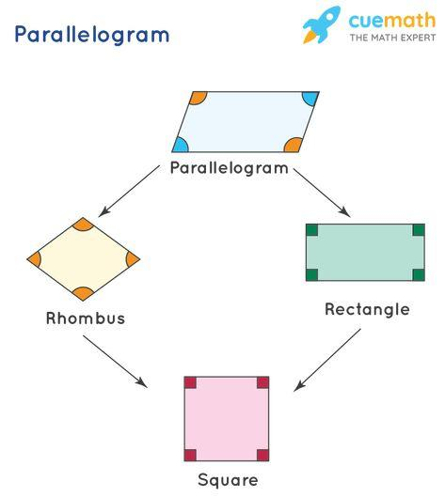
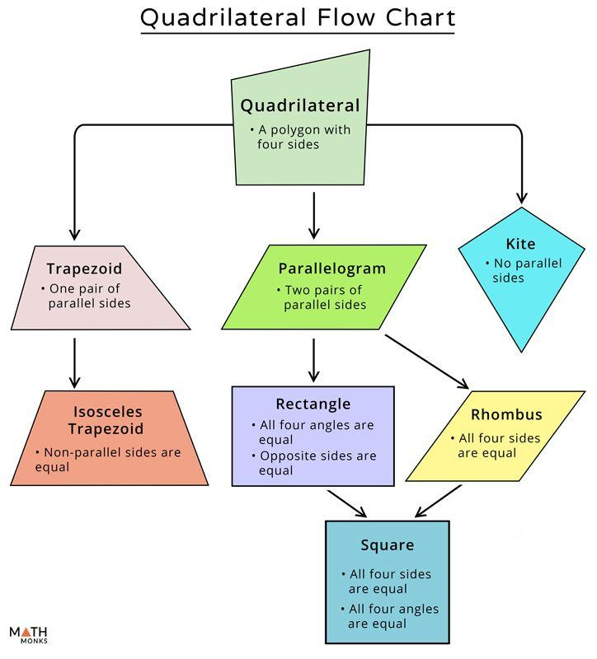
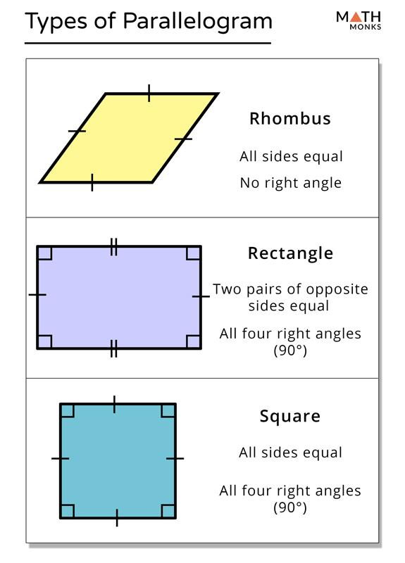
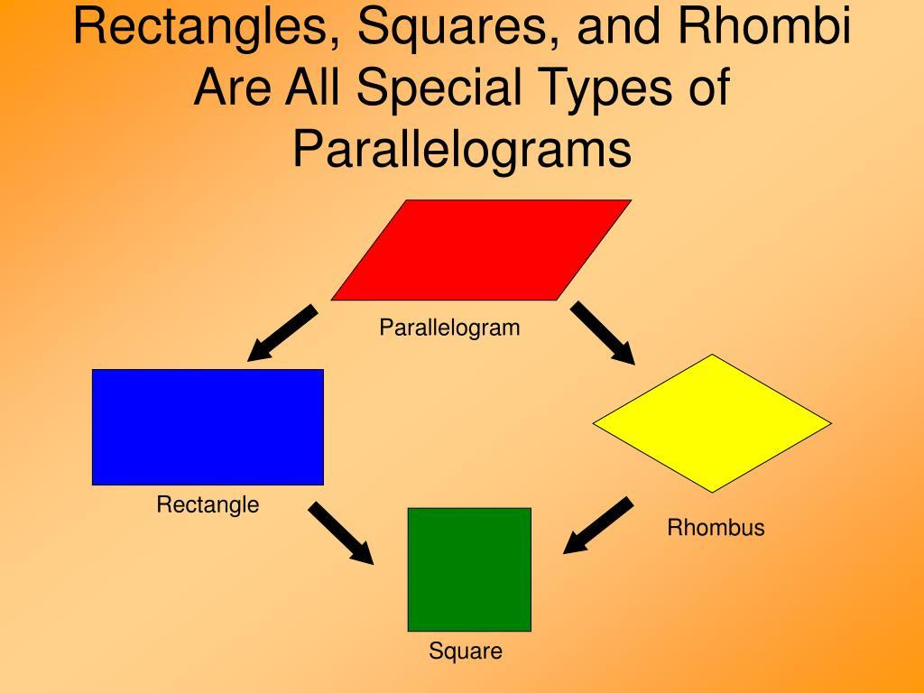
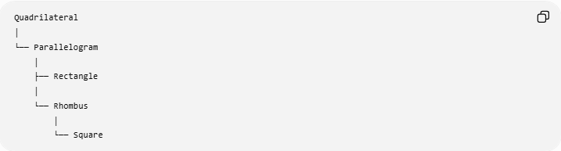
Quadrilateral
│
└── Parallelogram
│
├── Rectangle
│
└── Rhombus
│
└── Square
More precisely, rectangle and rhombus are both special types of parallelograms, while a square is both a rectangle and a rhombus.

Special Cases of Parallelograms
# Source: AI Source: Provided by: [Data Path: Persons Table -> ID Column: 1, Name_En Column: Motasem Essam] -> From: [ChatGPT] on [7/25/2026]
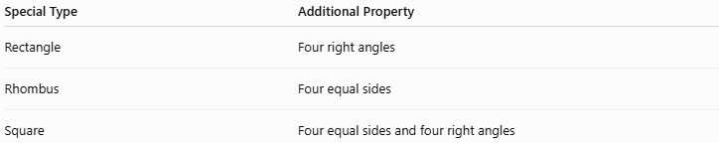
Special Type | Additional Property
Rectangle | Four right angles
Rhombus | Four equal sides
Square | Four equal sides and four right angles
So:
$$\boxed{\text{Parallelogram}+\text{4 right angles}=\text{Rectangle}} \\ \boxed{\text{Parallelogram}+\text{4 equal sides}=\text{Rhombus}} \\ \boxed{\text{Rectangle}+\text{4 equal sides}=\text{Square}}$$

Coordinate Geometry
# Source: AI Source: Provided by: [Data Path: Persons Table -> ID Column: 1, Name_En Column: Motasem Essam] -> From: [ChatGPT] on [7/25/2026]
A parallelogram can be represented using coordinates.
Suppose:
$$A\left(x_{1} , y_{1}\right), B\left(x_{2} , y_{2}\right), C\left(x_{3} , y_{3}\right), D\left(x_{4} , y_{4}\right)$$
One way to verify that opposite sides are parallel is to compare their slopes.
For example:
$$m_{AB}=m_{CD}$$
and:
$$m_{BC}=m_{AD}$$
when the slopes are defined.
Another method is to compare vectors:
$$\boxed{\vec{AB}=\vec{DC}}$$
and:
$$\boxed{\vec{BC}=\vec{AD}}$$

Examples

Example 1: Find a Missing Angle
# Source: AI Source: Provided by: [Data Path: Persons Table -> ID Column: 1, Name_En Column: Motasem Essam] -> From: [ChatGPT] on [7/25/2026]
A parallelogram has:
$$∠A={65}^{∘}$$
Since opposite angles are congruent:
$$\boxed{∠C={65}^{∘}}$$
Since consecutive angles are supplementary:
$$∠B={180}^{∘}-{65}^{∘} \\ \boxed{∠B={115}^{∘}}$$
and:
$$\boxed{∠D={115}^{∘}}$$

Example 2: Find a Missing Side
# Source: AI Source: Provided by: [Data Path: Persons Table -> ID Column: 1, Name_En Column: Motasem Essam] -> From: [ChatGPT] on [7/25/2026]
A parallelogram has:
$$AB=14\text{ cm}$$
Because opposite sides are congruent:
$$AB=CD$$
Therefore:
$$\boxed{CD=14\text{ cm}}$$

Example 3: Find a Diagonal Segment
# Source: AI Source: Provided by: [Data Path: Persons Table -> ID Column: 1, Name_En Column: Motasem Essam] -> From: [ChatGPT] on [7/25/2026]
The diagonals of parallelogram $ABCD$intersect at $O$.
Suppose:
$$AO=9\text{ cm}$$
Since the diagonals bisect each other:
$$AO=OC$$
Therefore:
$$\boxed{OC=9\text{ cm}}$$
The complete diagonal is:
$$AC=AO+OC \\ AC=9+9 \\ \boxed{AC=18\text{ cm}}$$

Example 4: Find the Area
# Source: AI Source: Provided by: [Data Path: Persons Table -> ID Column: 1, Name_En Column: Motasem Essam] -> From: [ChatGPT] on [7/25/2026]
A parallelogram has:
$$b=15\text{ m}$$
and:
$$h=8\text{ m}$$
Then:
$$A=bh \\ A=15\left(8\right) \\ \boxed{A=120{\text{ m}}^{2}}$$

Example 5: Determine Whether a Quadrilateral Is a Parallelogram
# Source: AI Source: Provided by: [Data Path: Persons Table -> ID Column: 1, Name_En Column: Motasem Essam] -> From: [ChatGPT] on [7/25/2026]
Suppose a quadrilateral has:
$$AB∥CD$$
and:
$$BC∥AD$$
Since both pairs of opposite sides are parallel:
$$\boxed{ABCD\text{ is a parallelogram}}$$

Ways to Prove a Quadrilateral Is a Parallelogram
# Source: AI Source: Provided by: [Data Path: Persons Table -> ID Column: 1, Name_En Column: Motasem Essam] -> From: [ChatGPT] on [7/25/2026]
A quadrilateral can be proven to be a parallelogram if any one of several sufficient conditions is established.
1. Both pairs of opposite sides are parallel
$$AB∥CD$$
and:
$$BC∥AD$$
2. Both pairs of opposite sides are congruent
$$AB=CD$$
and:
$$BC=AD$$
3. One pair of opposite sides is both parallel and congruent
For example:
$$AB∥CD$$
and:
$$AB=CD$$
4. Diagonals bisect each other
If:
$$AO=OC$$
and:
$$BO=OD$$
then the quadrilateral is a parallelogram.
5. Both pairs of opposite angles are congruent
$$∠A=∠C$$
and:
$$∠B=∠D$$
These are important parallelogram tests in deductive geometry.

Real-World Applications
# Source: AI Source: Provided by: [Data Path: Persons Table -> ID Column: 1, Name_En Column: Motasem Essam] -> From: [ChatGPT] on [7/25/2026]

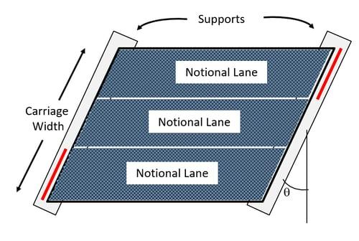

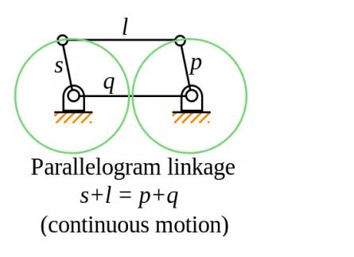

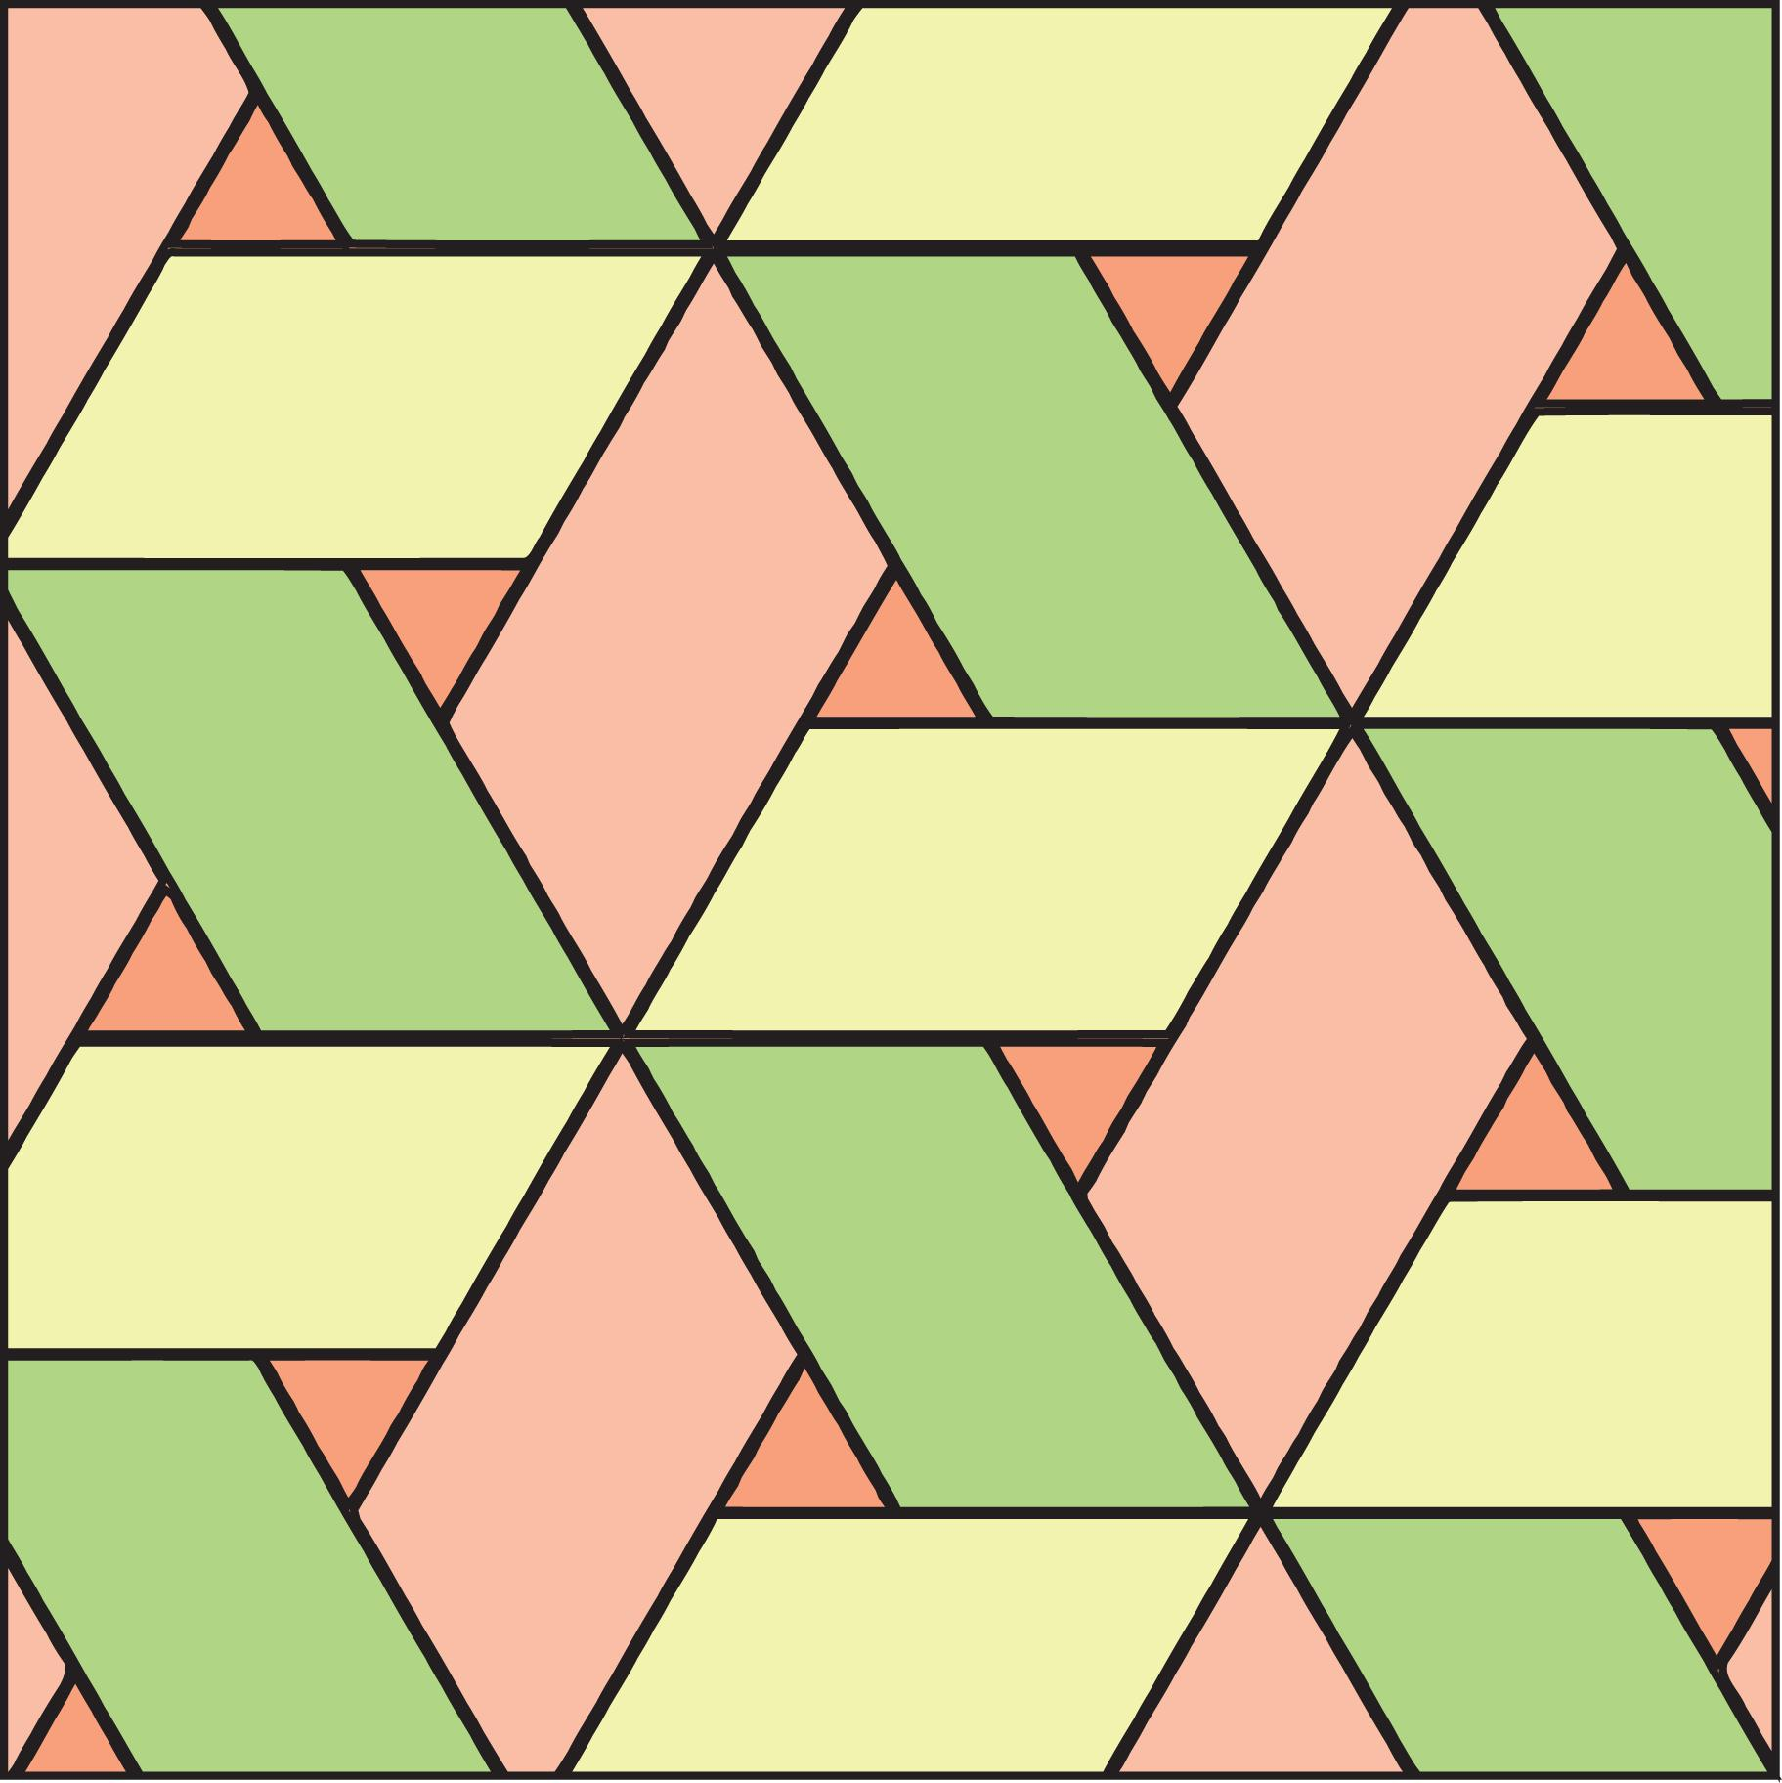
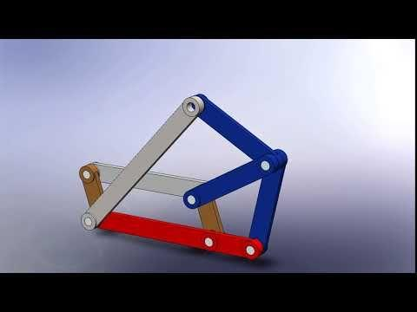
Parallelograms appear in:
- Architectural designs.
- Structural engineering.
- Mechanical linkages.
- Truss structures.
- Geometric patterns.
- Computer graphics.
- Technical drawings.
- Tiling and decorative designs.
- Vector and force diagrams.

Advantages
# Source: AI Source: Provided by: [Data Path: Persons Table -> ID Column: 1, Name_En Column: Motasem Essam] -> From: [ChatGPT] on [7/25/2026]
- Has clear and useful side and angle relationships.
- Simple formulas for perimeter and area.
- Diagonal properties provide useful geometric relationships.
- Forms the foundation for rectangles, rhombi, and squares.
- Important for vector geometry and coordinate geometry.

Limitations
# Source: AI Source: Provided by: [Data Path: Persons Table -> ID Column: 1, Name_En Column: Motasem Essam] -> From: [ChatGPT] on [7/25/2026]
- A general parallelogram does not necessarily have right angles.
- Its diagonals are not necessarily equal.
- Its diagonals are not necessarily perpendicular.
- The slanted side should not be confused with the perpendicular height when calculating area.
- Visual appearance alone cannot prove that a quadrilateral is a parallelogram.

Comparison with Related Quadrilaterals
# Source: AI Source: Provided by: [Data Path: Persons Table -> ID Column: 1, Name_En Column: Motasem Essam] -> From: [ChatGPT] on [7/25/2026]
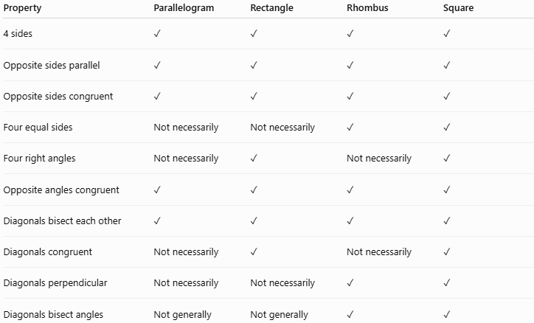
Property | Parallelogram | Rectangle | Rhombus | Square
4 sides | ✓ | ✓ | ✓ | ✓
Opposite sides parallel | ✓ | ✓ | ✓ | ✓
Opposite sides congruent | ✓ | ✓ | ✓ | ✓
Four equal sides | Not necessarily | Not necessarily | ✓ | ✓
Four right angles | Not necessarily | ✓ | Not necessarily | ✓
Opposite angles congruent | ✓ | ✓ | ✓ | ✓
Diagonals bisect each other | ✓ | ✓ | ✓ | ✓
Diagonals congruent | Not necessarily | ✓ | Not necessarily | ✓
Diagonals perpendicular | Not necessarily | Not necessarily | ✓ | ✓
Diagonals bisect angles | Not generally | Not generally | ✓ | ✓

Key Points
# Source: AI Source: Provided by: [Data Path: Persons Table -> ID Column: 1, Name_En Column: Motasem Essam] -> From: [ChatGPT] on [7/25/2026]
- A parallelogram is a quadrilateral with two pairs of opposite sides parallel.
- Opposite sides are congruent:
$$\boxed{AB=CD, BC=AD}$$
- Opposite angles are congruent:
$$\boxed{∠A=∠C, ∠B=∠D}$$
- Consecutive angles are supplementary:
$$\boxed{∠A+∠B={180}^{∘}}$$
- The diagonals bisect each other:
$$\boxed{AO=OC, BO=OD}$$
- Perimeter:
$$\boxed{P=2\left(a+b\right)}$$
- Area:
$$\boxed{A=bh}$$
- A rectangle is a special parallelogram with four right angles.
- A rhombus is a special parallelogram with four equal sides.
- A square is both a rectangle and a rhombus.

Conclusion
# Source: AI Source: Provided by: [Data Path: Persons Table -> ID Column: 1, Name_En Column: Motasem Essam] -> From: [ChatGPT] on [7/25/2026]
A parallelogram is a fundamental quadrilateral characterized by two pairs of parallel opposite sides. This single defining relationship produces several important consequences: opposite sides and angles are congruent, consecutive angles are supplementary, and the diagonals bisect each other. Rectangles, rhombi, and squares are all special types of parallelograms, making the parallelogram an essential concept in the classification and study of quadrilaterals.

